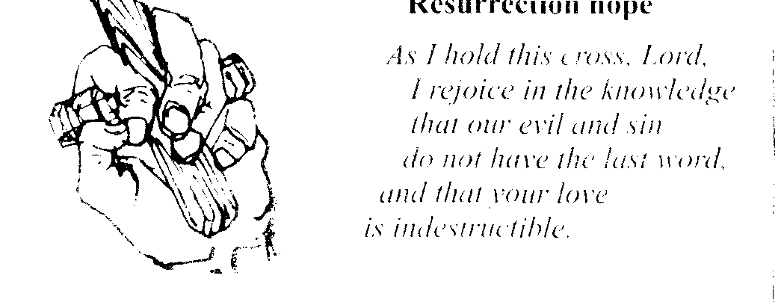
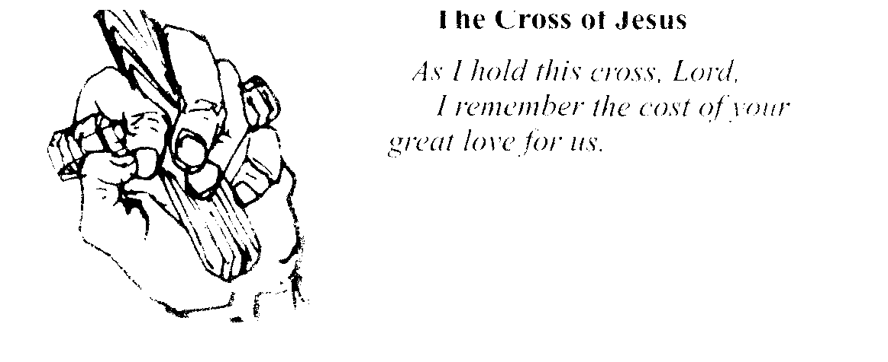
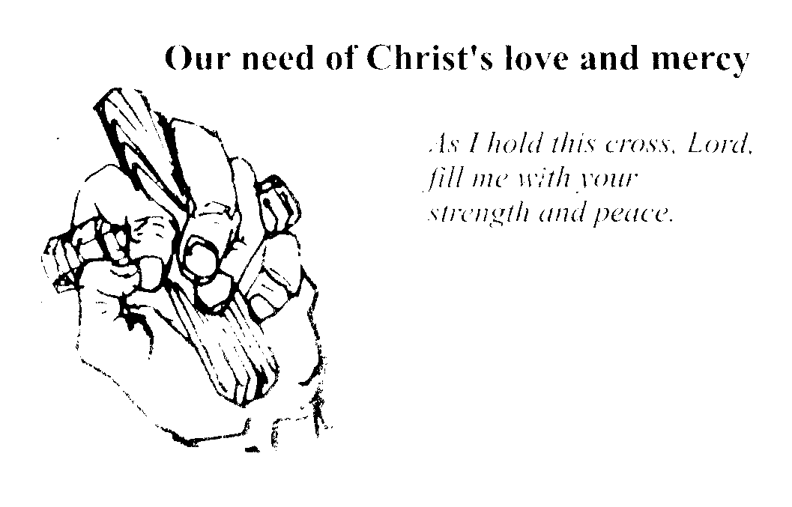
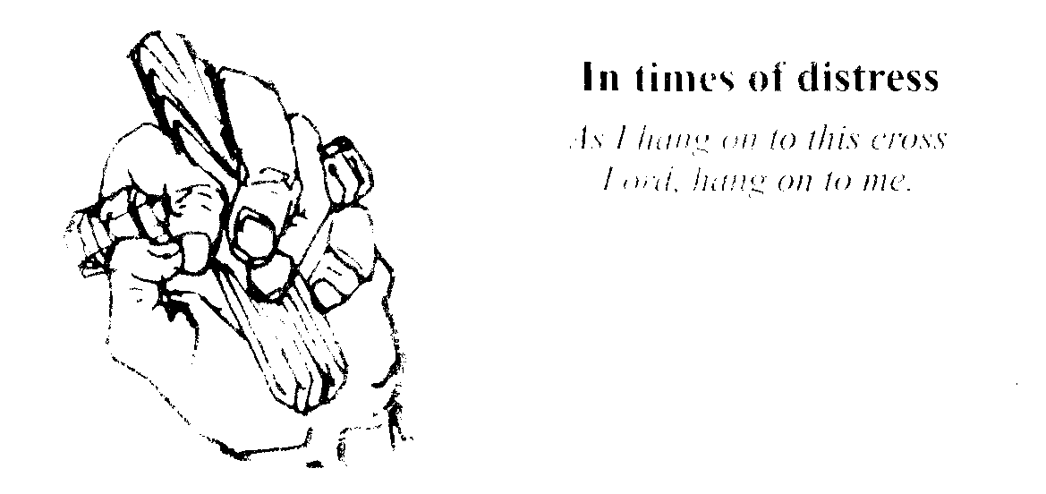
The Holding Cross
The cross beam is deliberately uneven, in order to fit between your fingers more comfortably than a correctly shaped’ cross would do.

Because a holding cross is not decorated or ornamental,
it is a true reminder of the harsh wood of the cross of Jesus.

Sometimes it is enough simply to hold the cross silently - this is itself prayer.
Maybe you have no words anyway, and it is through your sense, of touch that you are expressing your love of Christ and your need of him.

I will face this pain.
I will accept its full impact silently
turning my gaze onto the crucified Christ who is in this hell with me.
Even here I am held in the love of Jesus who is both love—
in death and Love—Risen.
Dear Lord and Saviour, Jesus Christ,
I hold up all my weakness to your strength.
My failure to your faithfulness,
my sinfulness to your perfection, my loneliness to your compassion,
my little pains to your great agony on the Cross.
I pray that you will cleanse me, strengthen me, and hide me,
so that, in all ways, my life may be lived, as you would have it lived,
without cowardice, and for you alone.
Come. O Christ my Light and illumine my darkness.
Come. my life, and revive me from death. Come my Physician,
and heal my wounds. Come.
Flame of divine love. and burn up the thorns of my sins
kindling my heart with the flame of your love.
For you alone are my King and my Lord.

Oh Lord. Jesus Christ,
stay beside me to defend me,
within me to guide me, before me to lead me,
behind me to guard me.
and above me to bless me that with you
and in you I may live and move and have my being,
for ever and ever.

Out of the depths I cry to you, 0 Lord,
Lord. hear my voice!
If you, Lord, should keep account of our sins,
Lord, who could stand?
But there is forgiveness with you,
so that you may ne revered.
I wait for the Lord, my soul waits for him,
and in his word is my hope.

In this thy bitter passion,
Good Shepherd think of me
With thy most sweet compassion
Unworthy though I be:
Beneath thy Cross abiding
For ever would I rest,
In thy dear love confiding,
And with thy presence blest.

Jesus, what have you not suffered,
what have you not given for me?
I can never comprehend you,
but I can love you and wonder
at the depth of the darkness which you entered,
and the cost of the love which you would not betray.

Soul of Christ, sanctify me;
Body of Christ, save me;
Water from the side of Christ, wash me;
Passion of Christ, comfort me;
Good Jesu, hear me;
Within your wounds, hide me
Never let me be separated from you;
In the hour of my death, call me,
That with the saints I may sing your pray
For ever and ever.

Lord, however fearful I may be,
I know that nothing can separate me from your love:
Neither death, nor life. angels nor principalities.
Things present, nor things to come, evil powers, heights,
depths or anything else in all creation — nothing at all!

For the courage of the martyrs, I thank you;
for the courage to stand up for what I believe, I ask you.
For the strength of all who died for you.
I thank you.
for strength to stand firm when the crowd disagrees, I ask you.
For the joy of your saints, I thank you;
for delight in the gift of each moment of life, I ask you.
Father of mercy, bless my efforts to love you,
and help me, in spite of my uncertainties,
to hear your call, trust your victory of love,
and surrender my life into your hands.
May the power of the cross, the joy of the resurrection,
and the presence of the risen Lord be with me, and all whom I love,
Amen.

